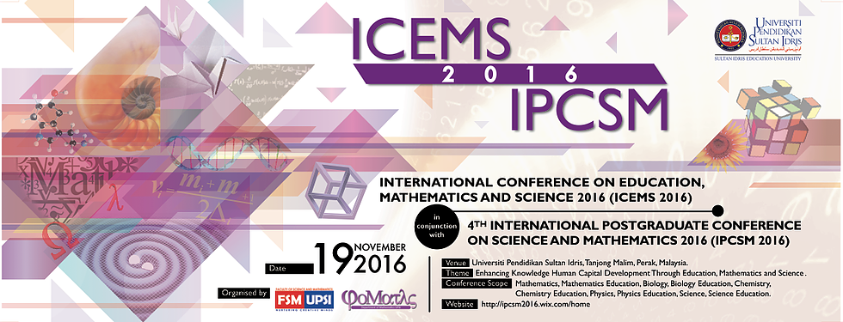

**REF: ICEMS|IPCSM|16|M009_1**

**An appointment as a reviewer ICEMS2016 in conjunction IPCSM2016**

Dear Dr. Nurul Akmal Mohamed,

On behalf of the committee members of ICEMS2016 in conjunction with IPCSM2016, we would like to appoint you as a reviewer for the paper entitled “**Application of Numerical Method in Calculating the Internal Rate of Return of Joint Venture Investment Using Diminishing Musyarakah Model**” for the Scopus-indexed AIP Conference Proceeding.

Kindly be informed that the dateline is "**January 4, 2017**". Please return the Reviewer Evaluation Form as well as the reviewed full paper (if necessary).

Herewith, we attach

i) The full paper to be reviewed

ii) AIP template as your reference

iii) Reviewer Evaluation Form.

Your commitment in ensuring the highest standards in the quality of the reviewed paper is highly appreciated.

If you have any further inquiries please do not hesitate to email us.

Thank you.

Best Regards,

Conference Paper Committee

ICEMS2016 in conjunction with IPCSM2016